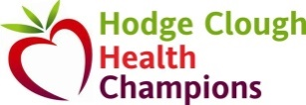
BE SUGAR SMART
The focus this term has been about reducing sugar in school snacks and lunch boxes. We are extremely impressed at the children’s enthusiasm and interest they have shown in checking labels. It has been lovely to hear them discussing their choices and sharing ideas in the dining hall and they have been so proud to tell us how many Golden Tickets they have received.
We also led a series of workshops and hope your children enjoyed showing you their booklets. Here are some of the facts they have learnt this term:
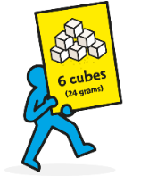
Children in primary school should have less than 24g of sugar per day.
Too much sugar can lead to the build up of harmful fat on the inside that we can't see. This fat around vital organs can cause weight gain and serious diseases in the future like heart disease, type 2 diabetes and some cancers. Having too much sugar can also cause tooth decay.
Fruit Juice and Smoothies are sugary. They still count towards your 5 a day but remember to limit the amount to 150ml per day.
You don’t need to worry about the sugar in milk, natural yoghurt or fresh fruits as these are not added sugars they are found naturally in the product; plus, these foods contain nutrients important for children’s development. Yoghurts contain calcium – great for bones and teeth. Again, check those labels and try to stick to low sugar varieties. By adding chocolate bits and other sweet things, manufacturers are adding sugar:
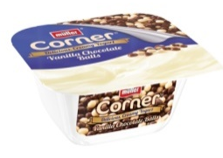
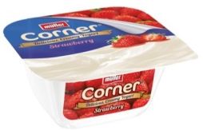
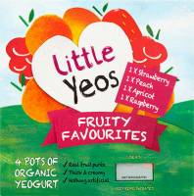

9.7g sugar per pot 18.9g sugar per pot 23.8g sugar per pot

SCHOOL DINNERS
Children on school dinners have also had a challenge this half term. We have been encouraging them to try a variety of vitamin rich vegetables and salad bar items. Again, they have been eager to take two or more items and have enjoyed receiving Golden Tickets for trying something new.

SCHOOL DINNERS & PACKED LUNCH UPDATE
Huge thanks go to our parents and carers that always support the school in the work that we do. We have been extremely pleased with the positive feedback from home and have seen a massive reduction in the amount of sugar in packed lunch boxes.
We are looking forward to the next half term when our Health Champions will launch another new initiative.
Packed Lunches
We hope our quick glance table to help make the guidelines and our policy clearer. Can we remind parents that the main course should be one item which is based around energy filled carbohydrates.
Main Course | Extra Calcium | Vitamin packed F & V | Additional dessert | Drink
Choose one; | Choose one or two; | As many as you like! | Just one item; | Water is available in the dining hall, or;
Carbohydrate based  Sandwiches  Pasta salad  Rice/couscous salad  Potato salad  Crackers with cheese  Instead of the above, you may like to occasionally send;  Sausage roll or other savoury pastry product | Cheese  One small piece / babybel / string  Yoghurt  Must be low sugar | Fresh fruit and vegetables  Dried fruit (30g)  - 1 heaped tablespoon of raisins/currants/mixed fruit  - 2 figs, 3 prunes  - 1 handful of dried banana chips.  Tinned / canned fruit  Canned in natural juice, not in syrup. | Recommended;  Currant tea cake / one slice fruit bread or malt bread  Plain rice/corn cakes, plain popcorn,  Sugar free jelly.  OR, your own choice which must be under 6g sugar; cake bar, biscuit. | Semi-skimmed or 1% milk.  Sugar free cordial  Fruit juice or Smoothie  150ml a day.

Foods we do not allow in school at any time
NUTS & NUT ALLERGIES
Please do not send nuts or any products containing nuts into school at any time. We have children in school with severe nut allergies.
- any form of crisps/baked crisps, cheddars or similar snacks
- sugary, flavoured popcorn
- breakfast cereal bars, biscuits, cakes over 6g sugar
- any chocolate items with more than 6g sugar
- fruit winders, compounded fruit bars/products
- milkshake, yogurt drinks
- NUTS

